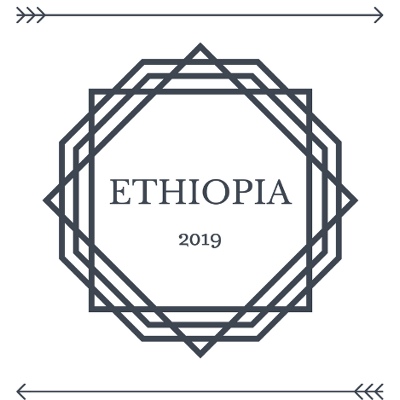
Hello!
I am very excited about the possible opportunity of getting to go to Ethiopia in the summer of 2019. I am currently in the application process with SIM (Serving in Mission) for this mission trip/internship.

Let me break some of the facts down about this trip...
Cost: Estimate for trip ~ $6,000
Estimate for additional trip supplies ~ $1,000
(Remember that these are estimates so they could go up or down)
I include such a high cost for additional trip supplies because of possible different clothes I may need to buy as well as any special supplies and possible visa costs if those are not included in the cost of the trip.
Length of trip: 3 months
Application fee: $30

There is quite a process to go through until this trip is set up and I am approved for it. I have filled out the first application and have had a phone interview, and have been approved for the second application process. Now I am filling out the second, more in-depth application.
So far, I have had nothing but a good experience with SIM and it is a unique situation because SIM was actually the first mission organization that I discovered when I first took and interest and felt God calling me to missions. I am excited to hopefully get the opportunity to work with them soon.
I am not sure exactly what this internship will look like right now so I am not able to give a lot of (or any) specifics right now but I would love and appreciate your prayers throughout this process!
I am also looking for donations for my $30 application fee. I currently have $20 that has already been donated that is going toward this fee, but I am in need of $10 more dollars.
In addition to financial help, I would love prayers for motivation... or maybe just against my own tendency to procrastinate.... in order to complete this larger application.
I love the trips and the opportunities that God gives me through them... but in a moment of raw honesty, I hate filling out applications. I think everyone does.

I am very excited and humbled to have this opportunity. This trip is very special to me not only because it is an opportunity for me to reach people with the love of Christ, but because I have felt called to work full-time as a bi-vocational missionary in Ethiopia for a very long time. Those of you who know me have heard of all of the crazy stories that I have told of how God has continually reminded me of the work that He wants me to be a part of in this country. I have tried and tried to go on mission trips to Ethiopia in the past and have continually received closed doors and a simple "no" from God, without understanding why. I have prayed for years for this opportunity and so far, deeply feel as if God has been saying "yes" to this opportunity.

I will continue to update everyone on this trip and I already know that God is going to continue to do amazing things as He always does!

Thank you for your support!

Rebekah Baughman
rbaughman505@gmail.com
217-823-4529

