Dear Supporter!

My trip to India with Rahab’s Rope was a success! Thank you for your support and prayers throughout this trip. So much happened in such a short period of time, but God was active in every moment. It was truly because of your thoughts and prayers, and because of our faithful God, that the whole team and I got into and out of India with safety and success. We were able to visit many amazing local ministries that Rahab’s Rope works with and we were able to share the love of Jesus with them. We visited a couple orphanages, a slum, several facilities for women who have been victims of human trafficking, an HIV/AIDS clinic, and work with a local pastor and translator. The team and I were able to organize Bible lessons, games, and activities for each day as well as take a day to sightsee and experience the beauty of the area that we were in. God’s hand was evident in all that we did and He protected us every step of the way. I can speak for the whole team when I say that we were truly blessed by this trip, and we all understood what God wanted for each of us through this trip. I have added some pictures from this trip to the bottom of this letter! All of the pictures that I am allowed to post will be on my website, rrmission.weebly.com , and I encourage you to visit that site to take a look at the rest of the pictures as well as my India trip journal entries that I am continuing to post!
Thank You!

Thank YOU for your support!

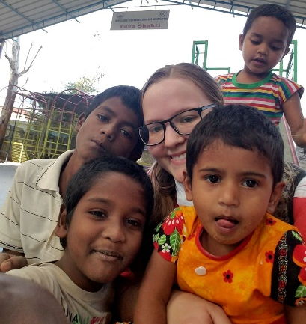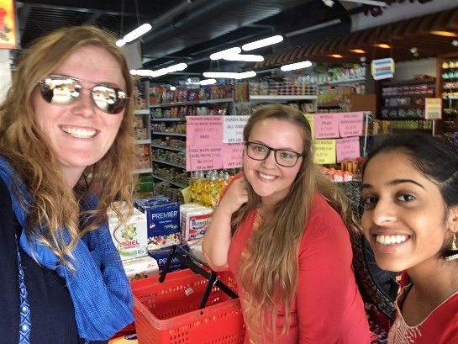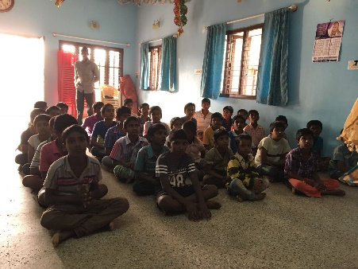
Rebekah Baughman

